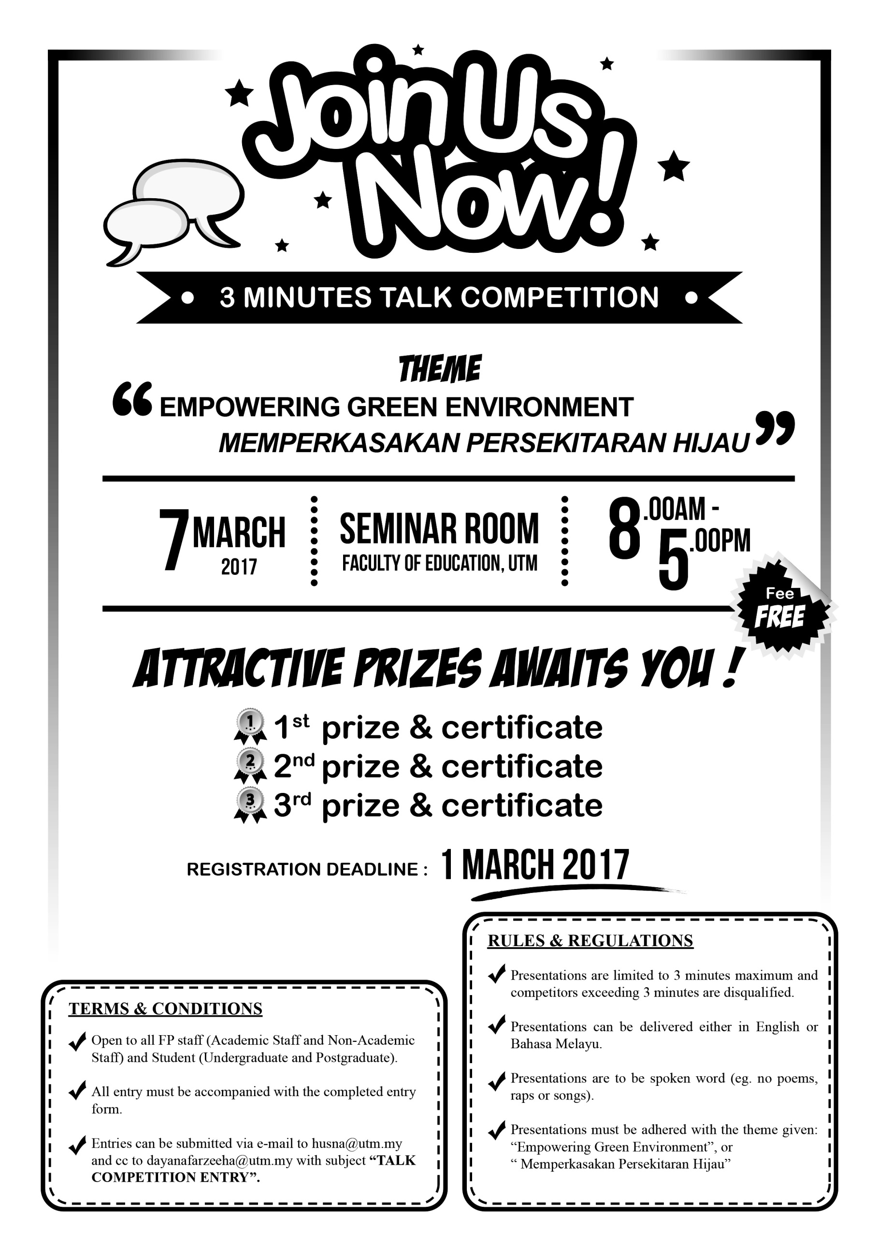

**Category :**

**Please Tick ( / )**

**/ /**

**/ /**

**Talk Title :**

**Name :**

**Contact Person :**

**Phone No. :**

**E-mail :**

